Park House School Safeguarding Policy and Child Protection Procedures 2025/26
Ryan Barlow
The Safeguarding Governor is: Julie Hamilton
James Madine
Jenny Turner
The name of the Chair of Governors is:
The Mental Health Lead in school is:
The Deputy Designated Safeguarding Lead(s) is:
The Designated Safeguarding Lead (DSL)
who takes the lead for Child Protection is: Ann-Marie Oliver
Ann-Marie Oliver
The Head teacher is:
This policy was developed on:
01:09:2025
This policy was signed off by the Governing Body:
01:09:2025
The policy will be reviewed on:
01:09:2026
The Safeguarding Quality Assurance Manager is: Martin Keightley

Safeguarding Children in Education Policy
PLEASE READ THIS DOCUMENT IN CONJUNCTION WITH ANY SPECIFIC LOCALISED PROCEDURES AS DIRECTED BY THE HEAD TEACHER.
Policy Number: | EDE/POL/002 | Author/Reviewer: | Martin Keightley  Kate Martin
Issue Number: | 008 | Approver: | James Madine
Issue Date: | 01/09/2025 | Service Type: | Education – England
Next Review Date: | 01/09/2026 | RADAR Location: | Education

Print & Keep on File: | Required ☑ | Not required ☐

ROLE/ORGANISATION | NAME | CONTACT DETAILS
Designated  Safeguarding Lead (DSL) | Ann-Marie Oliver | 01226 744870
Deputy DSL | Jennie Allport  Ryan Barlow | 07725 630 528  01226 744870
Local Authority Designated Officer  (LADO) | Sian Christian | 01226 772616
Chair of Governors | James Madine | 07773 474 876
Channel Helpline |  | 02073 407 264

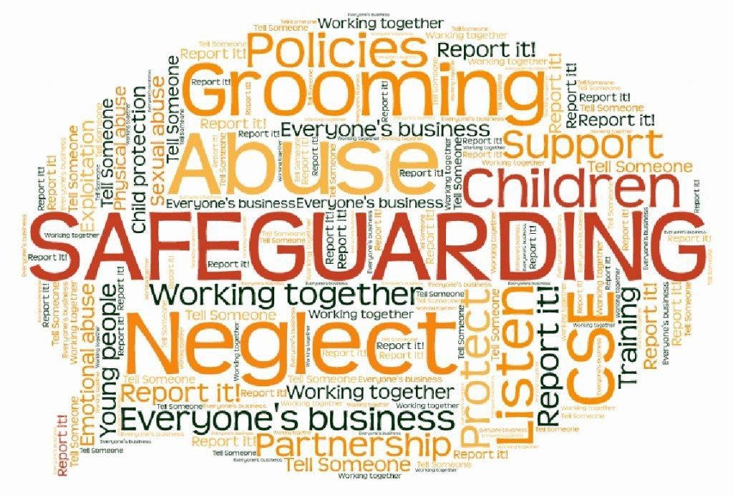

Contents
- Supporting Documents 4
- School Details 4
- Aims 4
- Definitions 5
- Roles and responsibilities 6
- Confidentiality and Information Sharing 10
- Concerns about a staff member, supply teacher, volunteer or contractor 11
- Child-on-child abuse 12
- Pupils with increased vulnerabilities 15
- Whistleblowing 16
- Training 16
- Monitoring Arrangements 17

Appendices
- Appendix 1: Procedures for Reporting and Recording 18
- Appendix 2: Recording and Storing Data 21
- Appendix 3: Recruiting and Selection Process 22
- Appendix 4: Safeguarding Champions Poster 27
- Appendix 5: Reporting and Referring Contact Information 28
- Appendix 6: Contextual Safeguarding Information and Location Risk Assessment 29
- Appendix 7: Safeguarding Oversight and Information Display 30
- Appendix 8: Body Map Guidance for Schools 32
- Appendix 9: Checklist for Staff and Governors 37
- Appendix 10: Useful Contacts within the Local Authority 39

- Supporting Documents

- PSHE Policy
- Alternative Provision Policy
- Behaviour and Anti-Bullying Policy
- Risk Assessment Policy
- First Aid Policy
- Exclusions Policy
- Attendance Policy
- Positive handling and Physical Intervention Policy
- Admissions Policy
- Whistleblowing Policy
- Keeping Children Safe in Education 2025
- Working Together to Safeguard Children
- Independent School Standards (Part 3)
- SEND Code of Practice
- Education Inspection Framework (EIF)

- School Details
See page 1 and 2
- Aims

This Safeguarding Policy has been developed in strict accordance with the statutory guidance outlined in Keeping Children Safe in Education (KCSIE) 2025, which all schools and colleges in England must follow when safeguarding and promoting the welfare of children under 18. It also aligns with the multi-agency framework established by Working Together to Safeguard Children, ensuring effective collaboration among all safeguarding partners and compliance with the Independent School Standards (Part 3 – Welfare, Health and Safety of Pupils). This framework sets out clear expectations for safeguarding arrangements, staff training, and leadership oversight.
This Safeguarding Policy will be regularly reviewed and updated to reflect the latest statutory guidance and best practices. We will incorporate technical changes from the Keeping Children Safe in Education 2025 guidance to improve the clarity and effectiveness of our safeguarding practices. This includes updating terminology, procedures, and training materials to ensure that our policy remains comprehensive and effective.
Our commitment to inclusivity is embedded throughout this policy, with a focus on recognising and addressing the needs of children with Special Educational Needs (SEN). For example, staff receive annual training on recognising signs of abuse in children with SEN, and our safeguarding team conducts regular reviews to ensure all procedures are adapted to meet the diverse needs of every child.
To maintain robust and up-to-date practices, we continually review and revise our policies in line with new statutory requirements or emerging guidance, referencing additional documents and updates as they become available. This ongoing process reassures stakeholders that our safeguarding approach remains thorough, compliant, and responsive to the evolving landscape of child protection. In alignment with the proposed Children’s Wellbeing and Schools Bill, our school is committed to enhancing the wellbeing of all children. We will implement practices and policies that promote mental health and emotional wellbeing, ensuring that children have access to the support they need to thrive in their educational environment.

- Definitions

Safeguarding and promoting the welfare of children involves:
- Protecting children from maltreatment both within and outside school settings, including online environments.
- Preventing impairment of children's mental and physical health or development.
- Ensuring children grow up in conditions that support safe and effective care.

Child Protection is included within this definition and refers to measures taken to prevent children from experiencing, or being at risk of experiencing, significant harm.
Abuse is defined as any form of maltreatment of a child, which may include causing harm or failing to act to prevent harm. This encompasses sexual, physical, and emotional abuse, all of which can occur either in person or online.
Neglect is classified as a type of abuse involving the continued failure to meet a child's basic physical and/or psychological needs, potentially resulting in serious impairment of health or development.
The sharing of nudes and semi-nudes (also referred to as sexting or youth-produced sexual imagery) is when children share nude or semi-nude images, videos, or live streams.
Our school recognises the importance of addressing group-based child sexual exploitation and abuse. We will incorporate emerging learnings from the National Audit on Group-based Child Sexual Exploitation and Abuse into our safeguarding practices. Staff will be trained to identify and respond to signs of exploitation and abuse, ensuring that children are protected and supported.
Children are defined as individuals under the age of 18.
Contextual safeguarding acknowledges that children can encounter risks in various settings, including school, neighbourhoods, online platforms, and with peers, not solely at home. There is a duty to address risks in broader environments, such as radicalisation, exploitation, youth violence, gangs, digital or AI-related concerns, inappropriate relationships, and unsafe community spaces. Contextual safeguarding risk assessments (referenced in Appendix 7) should be reviewed termly by the DSL and reported to governors.
Safeguarding partners are designated in Keeping Children Safe in Education 2025 (further defined in the Children Act 2004, as amended by chapter 2 of the Children and Social Work Act 2017). These partners collaborate to safeguard and promote local children's welfare, including identifying and addressing their requirements. Partners include:
- The local authority (LA).
- Integrated care boards within the LA area.
- The chief officer of police for a police area within the LA.

"Victim" is a commonly used term; however, it is recognised that not all individuals affected by abuse identify with this description. During incident management, terminology will be selected according to the preferences of the child involved.
"Alleged/perpetrator(s)" are standard terms, but abusive behaviour may also impact the individual responsible, particularly if they are a child. Care will be taken to use language that does not stigmatise or shame. Alternative terms include "person alleged to have caused harm" or "the individual involved". Terminology will be decided on a case-by-case basis.
- Roles and responsibilities

Safeguarding and child protection are everyone’s responsibility.
This policy is applicable to all staff, volunteers, and governors within the school and aligns with procedures set forth by the three safeguarding partners. The scope also extends to cover extended school and off-site activities. It is our duty to ensure any alternative provision employed upholds robust and appropriate safeguarding measures. The practices described herein are consistent with the Non-Association Independent School Inspection Handbook, particularly concerning Leadership and Management—where safeguarding serves as a limiting judgement factor—as well as the Independent School Standards. Clear accountability, escalation protocols, and demonstrable safeguarding practices directly contribute to positive inspection outcomes; thus, all staff must be fully conversant with their obligations.

All staff are required to:
- Read and understand Keeping Children Safe in Education (KCSIE) Part 1 and Annex B, review it annually, and affirm their understanding via a signed declaration each academic year.
- Reinforce online safety when communicating with parents/carers, including guidance on children's online activities.
- Provide safe spaces for LGBTQ+ pupils to express concerns.

All staff will also be aware of and utilise:
- The school's safeguarding infrastructure (this policy, behaviour policy, online safety policy, CPOMS, DSL/deputies, response protocols for missing education).
- Their role in early intervention (identifying emerging concerns, liaising with the DSL, and sharing pertinent information).
- Procedures for referring cases to children’s social care and statutory assessments, and their potential involvement in these processes.
- Appropriate responses to child disclosures of abuse or neglect, including FGM, maintaining confidentiality, and collaborating with professionals.
- Indicators of abuse or neglect and specific issues such as peer-on-peer abuse, CSE, CCE, serious violence/county lines, radicalisation, and FGM.
- The importance of reassuring children that their concerns are taken seriously and support will be provided.
- Recognition that risks may arise both inside and outside the home, in school, or online.
- Awareness that LGBTQ+ children, or those perceived as such, may experience additional risks.
- Understanding that children with SEN are at greater risk and may face further vulnerabilities compared to their peers without SEN.

Designated Safeguarding Lead (DSL)
The DSL, a middle or senior leader, holds primary responsibility for child protection and safeguarding, including online safety and filtering/monitoring.
DSL
- Keep senior leadership informed.
- Liaise with the local authority, LADO, police, and safeguarding partners.
- Maintain awareness of local specialist support available for victims and alleged perpetrators.
- Ensure the presence of an “appropriate adult” during police involvement with students.

Headteacher Responsibilities
The Headteacher is accountable for:
- Inducting all staff and volunteers (including temporary personnel) into the school’s safeguarding systems and procedures and ensuring adherence to referral processes.
- Acting as the “case manager” for allegations concerning staff or volunteers.
- Making determinations on low-level concerns (consulting the DSL as appropriate).
- Communicating this policy to parents/carers and ensuring publication on the school website.
- Providing the DSL with sufficient time, training, and resources.

Governing Board Responsibilities
The Governing Board shall:
- Implement a whole-school approach to safeguarding, integrating it across all policies and processes.
- Approve and annually review this policy, ensuring compliance, and hold the Headteacher accountable.
- Fulfil duties pertaining to the Human Rights Act 1998, Equality Act 2010, and local safeguarding arrangements.
- Appoint a senior board-level lead (Julie Hamilton, Group Safeguarding Director) independent of the DSL, to oversee the efficacy of safeguarding policies.
- Ensure mandatory safeguarding/child protection training for all staff, inclusive of online safety, with regular updates.
- Oversee the implementation of suitable filtering and monitoring systems, ensuring comprehension among staff and alignment with DfE standards.
- Grant the DSL the requisite authority, resources, and time necessary to execute their role.
- Ensure processes are established for managing low-level concerns and compliance with these procedures (see section 5).
- Where external organisations use school facilities/services:
- Require them to maintain appropriate safeguarding procedures.
- Mandate necessary liaison with the school.
- Make safeguarding compliance a precondition for use.
- Appoint a Governor as “case manager” should there be allegations against the Headteacher.

Contextual Risk Assessment
Contextual Risk Assessments identify risks to pupils beyond the home, including within the local community and physical risks in or near the school environment. These assessments must be completed at the beginning of the school year in accordance with KCSIE updates and reviewed at the start of each term by the DSL and Leadership Team. Templates should be completed comprehensively and updated with input from local intelligence sources (police, local authority safeguarding teams, and community partners). Reviews will be minuted, and outcomes communicated to staff as appropriate. Governors will review the updated assessments each term.
Oversight and Quality Assurance
Governors, the Education Director, and the Keys Safeguarding Compliance Team have explicit oversight functions, including regular analysis of safeguarding data, termly reviews of contextual safeguarding risk assessments, and clear escalation procedures in instances where risks or deficiencies are identified. This structure satisfies inspection criteria requiring governance to demonstrate strategic challenge and effective oversight. Further details can be found in the appendices.
Preventative Education Responsibilities
The school plays an integral part in preventative education, adopting a whole-school approach to equip pupils with the knowledge and skills necessary for life in contemporary Britain. A zero-tolerance culture towards sexism, misogyny/misandry, homophobia, biphobia, transphobia, and sexual violence/harassment underpins this work, supported by our:
- Behaviour Policy
- Pastoral support system
- Regularly delivered, inclusive PSHE and RSHE curriculum encompassing:
- Healthy and respectful relationships
- Boundaries and consent
- Stereotyping, prejudice, and equality
- Hate speech versus free speech
- Body confidence and self-esteem
- Recognition of abusive relationships, including coercive and controlling behaviours
- Laws relating to sexual consent, exploitation, abuse, grooming, harassment, rape, domestic abuse, forced marriage, honour-based violence, FGM, and access to support
- What constitutes sexual harassment and sexual violence, and unequivocal condemnation of such behaviour
- Bullying and discrimination (including racism, ableism, sexism, homophobia, transphobia, and other forms of prejudice)
- Online safety (privacy, digital footprint, misinformation/disinformation, cyberbullying, gaming risks, AI/deepfake challenges)
- Mental and physical health and self-care
- Diversity and inclusion (celebrating differences, disability awareness, LGBTQ+ inclusion)
- Exploitation and broader contextual risks
- Economic wellbeing and online pressures (advertising, scams, gambling, financial decision-making)
- Preparation for independence (safe travel, responsible decision-making, personal responsibility).

Our school is dedicated to tackling violence against women and girls. We will implement
preventative education programmes that address this issue, promoting a culture of respect and safety for all students. Staff will be trained to recognise and respond to signs of violence and abuse, ensuring that appropriate support and interventions are provided.

- Confidentiality and Information Sharing

Confidentiality is essential to uphold the dignity and privacy of individuals involved in safeguarding matters; however, prompt information sharing remains a critical aspect of effective safeguarding. Staff should not allow concerns about information sharing to hinder their responsibility to protect children.
The following measures are implemented to ensure effective practice:
- Confidential records are securely maintained on CPOMS, accessible only by those with a legitimate professional need.
- Collaboration with the Data Protection Officer, as appropriate, ensures that the Data Protection Act 2018 and UK GDPR do not impede the sharing of information necessary to safeguard children.
- Staff must never guarantee confidentiality to any child who discloses, or is affected by, abuse or neglect.
- The Designated Safeguarding Lead (DSL) will consider the child's wishes while ensuring the primary duty to protect the child and others is upheld.
- In most cases, parents or carers will be informed unless doing so would increase the risk to the child. It is the responsibility of the DSL or Headteacher to notify parents or designate an appropriate staff member for this task.
- If a child is at risk, in danger, or has been harmed, a referral must be made to children’s social care.
- Incidents involving rape, assault by penetration, or sexual assault must also be reported to the police, even if the alleged perpetrator is under the age of ten.
- Staff recognise the importance of maintaining anonymity and adhere to the 7 golden rules of information sharing as advised by DfE guidance.
- Where uncertainty exists, staff should consult the DSL or Headteacher.

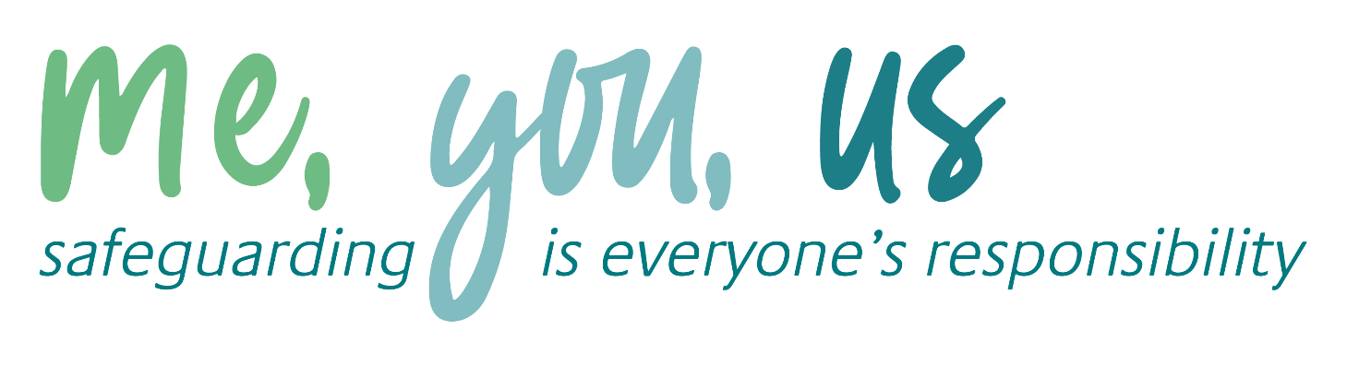

Figure 1: procedure if you have concerns about a child’s welfare (as opposed to believing a child is suffering or likely to suffer from harm, or in immediate danger)
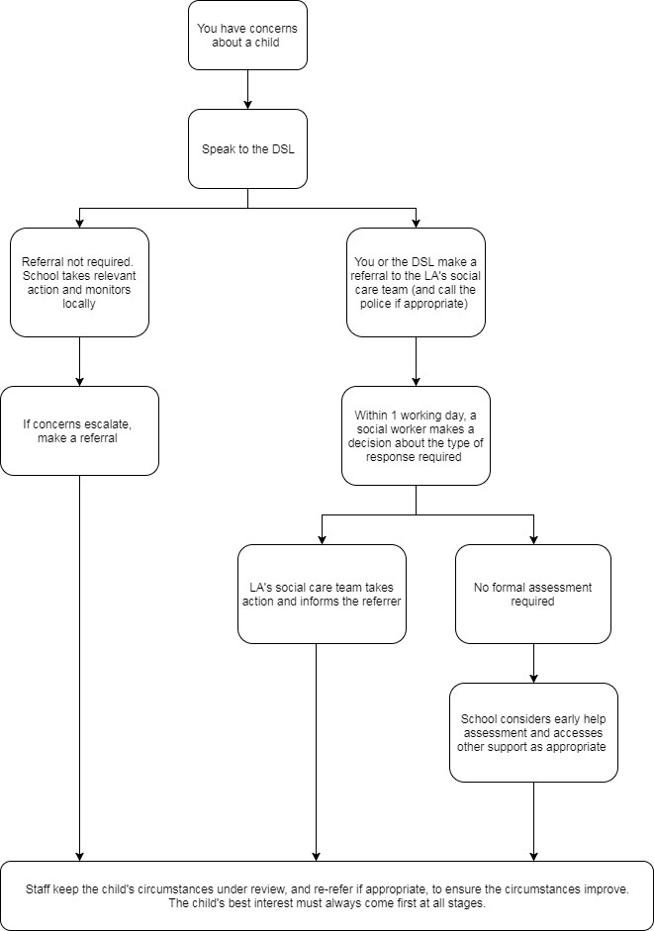
(Note – if the DSL is unavailable, this should not delay action. See section 7.4 for what to do).

- Concerns about a staff member, supply teacher, volunteer or contractor

If there are concerns regarding any individual employed in the school, whether directly or through a contract, who may pose a risk of harm to children, or if an allegation is made, all staff must report this to the Headteacher immediately, and no later than the end of the working day. Should the concern or allegation pertain to the Headteacher, it is the responsibility of all staff members to notify the Executive Headteacher. If the concern is relating to the Executive Headteacher then you must inform the Chair of Governors (James Madine).
The Headteacher or the Chair of Governors will then proceed in accordance with the procedures outlined in Appendix 3, where applicable.
In cases where the concern or allegation involves a member of staff—including supply teachers, volunteers, or contractors—who may pose a risk of harm to children, staff should speak with the DSL and/or Headteacher as soon as possible. If the Headteacher is the subject of the concern or allegation, staff should escalate the issue to the Headteacher’s line manager.
If a conflict of interest exists in reporting a concern or allegation about any individual working within the school to the Headteacher, staff are permitted to report the matter directly to the Regional Executive Headteacher or the Regional Director in the first instance.

Low Level Concerns

A low-level concern refers to any issue, regardless of its significance, including those that may simply cause unease or a sense of ‘nagging doubt’. Such concerns arise when an adult working in or on behalf of the school is perceived to have acted in a manner inconsistent with the Group’s code of conduct—this encompasses inappropriate conduct outside of work—but does not meet the threshold for an allegation or warrant a referral to the local authority designated officer.
Examples of low-level concerns include, but are not limited to:
- Demonstrating excessive familiarity with students, leading to blurred boundaries.
- Displaying favoritism or engaging with a student one-on-one in a secluded area or behind a closed door.
- Using inappropriate or offensive language.

All staff are required to report low-level concerns to the Headteacher at the earliest opportunity. Whenever feasible, this should be communicated via email; if reported verbally, the Headteacher will document the conversation in writing.
Headteachers are responsible for maintaining comprehensive records of all low-level concerns and actions taken.

- Child-on-child abuse

It is recognised that children may sometimes abuse other children. Such behaviour will not be tolerated or dismissed as banter, humour, or part of growing up, as this could contribute to inappropriate behaviour and an unsafe environment for students.
Allegations of abuse made against other pupils (known as child-on-child abuse)
Incidents where pupils harm others are typically addressed under the school’s behaviour policy. However, this policy will apply to cases involving safeguarding concerns, such as when alleged behaviour:
- Is serious and potentially constitutes a criminal offence.
- May put pupils at risk.
- Involves coercion or forcing pupils to use drugs or alcohol.
- Involves sexual exploitation, abuse, or harassment, including indecent exposure, sexual assault, upskirting, sharing of indecent images (including nudes and semi-nudes), or creating deep-fake explicit images.

Procedures for dealing with allegations of child-on-child abuse
Allegations by a pupil against another pupil will follow established safeguarding procedures (see Appendix 1 section A and B), reported to the DSL and recorded on CPOMS.
If the incident involves a potential criminal offence and there are delays in the criminal process, the DSL will cooperate with the police and other agencies as needed, while taking necessary measures regarding student safety and discipline.
Creating a supportive environment to minimise the risk of child-on-child abuse
The importance of proactive action to reduce risks associated with child-on-child abuse and fostering a supportive reporting environment is acknowledged.
To support this, the school will:
- Address derogatory or sexualised language and inappropriate behaviour between students.
- Monitor issues that affect different genders.
- Use the curriculum to educate pupils about appropriate, socially expected, and criminal behaviour, with particular attention to students with SEN who may find these concepts challenging.
- Ensure accessible reporting systems for all pupils.
- Remain alert to reports of violence or harassment, particularly those of a sexual or discriminatory nature, which may indicate broader issues. Identified issues will be handled through curriculum adaptation, staff training, policy updates, and, if suitable, collaboration with safeguarding partners.
- Provide support for students affected by or witnessing child-on-child abuse, ensuring that all parties involved are protected from bullying or harassment.
- Train staff to recognise indicators of child-on-child abuse and to respond appropriately, maintaining an outlook that such abuse could occur even in the absence of reports.

Disciplinary measures may proceed alongside external investigations, such as those by law enforcement. The school will determine on a case-by-case basis whether disciplinary actions might affect ongoing investigations and will consult with appropriate authorities as needed. Consideration will also be given to circumstances where conducting an internal review may not be reasonable during an independent investigation.
Sharing of nudes and semi-nudes (‘sexting’)
Current guidance for educational settings (UK Council for Internet Safety, 2024) defines this as sending or posting nude or semi-nude images, videos, or live streams online by individuals under 18. Alternative terminology may include ‘dick pics’ or ‘pics’. Motivations behind sharing such imagery may not always be sexual or criminal.
This guidance does not apply to adults sharing images of individuals under 18. Such behaviour is categorised as child sexual abuse and must be reported to police immediately.
All staff are required to follow reporting and recording protocols as outlined in Appendix 1 Sections A and B.
Staff must not:
- Delete any image or instruct a pupil to do so
- View, copy, print, share, store, or retain such imagery or ask a pupil to do so; doing so can constitute a criminal offence. If imagery is viewed inadvertently, staff must report this to the DSL in writing immediately.

In exceptional situations, the DSL (or equivalent) may view the image solely for safeguarding purposes, using professional judgement.
Referring to the police
Decisions to refer incidents to the police or social care will be made individually, considering all relevant context. Where referral is required, the DSL (or Headteacher) will contact the police via 101.
Escalation of Concerns
Each school is required to maintain a clearly defined escalation procedure, which must be communicated to all staff and prominently displayed on the school safeguarding board. In situations where the escalation pertains to an external agency’s response, the Designated Safeguarding Lead (DSL) should ensure that the concern is raised with the next appropriate level within that agency, such as a line manager.
While there may be minor procedural differences between sites, the escalation process must incorporate the following:
Report the concern in accordance with the procedure outlined in Appendix 1. If necessary, escalate to the Safeguarding Quality Manager for additional support or guidance, ensuring the relevant governor and Education Director/Regional Director are copied in. Should further escalation be required, involve the Safeguarding Director.
If any concern relates to the Headteacher, the Safeguarding Governor and the Education Director must be informed to ensure the issue is addressed externally from the school. Further guidance on this matter can be found in Section 5.
- Pupils with increased vulnerabilities

Pupils with Special Educational Needs or Health Conditions
We acknowledge that pupils with special educational needs (SEN) or certain health conditions may experience heightened safeguarding challenges and are statistically more susceptible to abuse than their peers.
Recognising abuse and neglect within this group can present additional complexities, such as:-
- Attributing indicators of possible abuse—including changes in behaviour, mood, or injury—solely to the child’s needs or health condition without adequate investigation;
- The potential for pupils with SEN, disabilities, or specific health conditions to be disproportionately affected by behaviours such as bullying, even if they do not display outward signs;
- Communication barriers and challenges in reporting or managing these concerns.

To address these issues, we provide targeted training for staff on specific safeguarding considerations related to pupils with SEN and health conditions.
Pupils with a Social Worker
Some pupils require the support of a social worker due to safeguarding or welfare concerns. We recognise that adverse experiences and trauma can increase a child’s vulnerability to further harm and impact attendance, learning, behaviour, and mental health.
The Designated Safeguarding Lead (DSL) and all staff members collaborate closely with social workers to protect vulnerable children.
When it is known that a pupil has a social worker, the DSL always considers this information to ensure decisions prioritise the pupil’s safety, welfare, and educational outcomes. For instance, this may guide responses to:
- Unauthorised absences or missing education where safeguarding risks are identified;
- Provision of pastoral or academic support as appropriate.

Looked-after and Previously Looked-after Children
We are committed to ensuring that staff possess the knowledge, skills, and understanding necessary to safeguard looked-after and previously looked-after children. Specifically, we ensure that:
- Relevant staff members are informed about children’s legal care status, contact arrangements with birth parents or individuals with parental responsibility, and current care provisions;
- The DSL maintains up-to-date details of each child’s social worker and relevant virtual school headteachers.

The Headteacher is responsible for promoting the educational achievement of looked-after and previously looked-after children. As part of this role, the Headteacher will:
- Work in partnership with the DSL to ensure safeguarding concerns regarding looked-after and previously looked-after children are addressed swiftly and effectively;
- Collaborate with virtual school heads to support and enhance the educational progress of these children.

- Whistleblowing

Keys Group maintains a distinct Whistleblowing Policy addressing issues related to the safeguarding of pupils, encompassing concerns about inadequate or unsafe practices or possible failures. This policy is available for reference on RADAR.

- Training

Staff and governors should consult Appendix 9: Checklist for Governors, which outlines statutory duties and procedural requirements for induction and refresher training.
All staff
All staff participate in safeguarding and child protection training as part of their induction, including training related to whistleblowing procedures and online safety, to ensure familiarity with the school’s safeguarding systems and responsibilities, as well as recognition of potential indicators of abuse or neglect.
Training is updated regularly and designed to:
- Be embedded within the whole-school safeguarding policy, wider staff training, and curriculum planning.
- Align with the guidance provided by safeguarding partners.
- Address online safety expectations, roles, and responsibilities regarding filtering and monitoring.
- Reference Teachers’ Standards, supporting expectations that all teachers:
- Manage behaviour appropriately to maintain a safe environment.
- Understand the needs of all pupils.
All staff complete training on the government’s anti-radicalisation strategy, Prevent, aimed at recognizing children at risk of involvement in terrorism and addressing extremist ideas.
Ongoing safeguarding and child protection updates, including topics on online safety, are provided as needed, and at least annually (for example, via emails, e-bulletins, or staff meetings).
Volunteers receive relevant training where applicable.
The DSL and Deputy DSLs
The Designated Safeguarding Lead (DSL) and Deputy DSL undertake Level 3 child protection and safeguarding training at least every two years.
They also update their knowledge and skills regularly, at least annually, using resources such as e-bulletins, networking with other DSLs, attending Keys Education DSL events, or reviewing current safeguarding developments.
Prevent awareness training is also completed by the DSL and Deputy DSL.
Governors
All governors complete at least Level 3 safeguarding and child protection training (including online safety) during their induction, with regular updates. This ensures they:
- Possess the necessary knowledge and information to perform their functions and understand their responsibilities, including providing strategic challenge.
- Can confirm that safeguarding policies and procedures are effective in delivering a comprehensive approach to safeguarding.
The Chair of Governors receives additional training in managing allegations, as they may need to act as the ‘case manager’ if an allegation is made against the Headteacher.
Recruitment – interview panels
At least one member of every interview panel completes safer recruitment training, which covers at minimum the contents of Keeping Children Safe in Education and complies with local safeguarding procedures.
Staff who have contact with pupils and families
Staff working directly with children and families participate in supervision sessions with their line manager. These sessions offer support, coaching, training, promote the interests of children, and provide opportunities for confidential discussions of sensitive issues.

- Monitoring arrangements

This policy will be reviewed annually by the Keys Group and the Headteacher

At every review, it will be approved by the full governing board.

Appendix 1: Procedures for Reporting and Recording

Recognising Abuse and Taking Action
All staff members, volunteers, and governors are required to adhere to the following procedures in the event of a safeguarding concern.
Please note: In this and subsequent sections, any reference to the Designated Safeguarding Lead (DSL) also applies to any deputy DSL.
Section A - Immediate Actions if a Child is Suffering or Likely to Suffer Harm, or is in Immediate Danger
- Report the concern to the DSL. If the DSL is unavailable, report to the Headteacher. If neither is available, you must immediately refer the matter to children’s social care and/or the police if you believe a child is at risk of harm or in immediate danger. Any individual can make such a referral.
- Document all details related to the concern and/or referral on CPOMS as soon as possible, and no later than the end of the working day.

Section B - Responding to a disclosure of a safeguarding issue by a child
- Listen attentively and take the disclosure seriously, allowing the child sufficient time to express themselves without asking leading questions.
- Remain calm and do not display shock or distress.
- Acknowledge the child's decision to confide in you and refrain from suggesting they should have disclosed sooner.
- Explain the next steps, clarifying that you are obligated to share this information. Do not promise confidentiality.
- Record the conversation at the earliest opportunity on CPOMS, prior to the close of the working day. Ensure an objective account is provided, delineating direct quotations from the child using quotation marks.
- Follow the reporting procedures outlined in Section A.

Section C - Addressing concerns not based on direct disclosure
Be mindful that some children may:
- Not feel prepared or know how to disclose abuse, exploitation, or neglect.
- Fail to identify their experiences as harmful.
- Feel embarrassed, ashamed, or threatened. These feelings may arise due to vulnerability, disability, sexual orientation, or language barriers.

These factors must not deter you from exercising professional curiosity. If you have concerns about a child, consult the DSL and ensure these concerns are recorded on CPOMS promptly. If necessary, follow the processes described in Section A.
Section D - Female Genital Mutilation (FGM)
Any teacher who becomes aware or has credible evidence that a child has been subjected to FGM, as defined below, is legally required to report this directly and immediately to the police. This statutory duty carries disciplinary consequences for non-compliance. The requirement does not apply in cases where a pupil is at risk of FGM or suspicion exists without confirmation. Staff must not physically examine pupils. If there is risk or suspicion, teachers should follow the procedures detailed in Section A.
Unless instructed otherwise, staff should also discuss the case with the DSL and involve children’s social care as appropriate.
Definition of FGM:
Keeping Children Safe in Education explains that FGM comprises “all procedures involving partial or total removal of the external female genitalia, or other injury to the female genital organs”.

FGM is illegal in the UK and a form of child abuse with long-lasting, harmful consequences. It is also known as ‘female genital cutting’, ‘circumcision’ or ‘initiation’.

Possible indicators that a pupil has already been subjected to FGM, and factors that suggest a pupil may be at risk, are set out in appendix 4 of this policy.

Any teacher who either:

- Is informed by a girl under 18 that an act of FGM has been carried out on her; or
- Observes physical signs which appear to show that an act of FGM has been carried out on a girl under 18 and they have no reason to believe that the act was necessary for the girl’s physical or mental health or for purposes connected with labour or birth

Must immediately report this to the police, personally.

This is a mandatory statutory duty, and teachers will face disciplinary sanctions for failing to meet it. Unless they have been specifically told not to disclose, they should also discuss the case with the DSL and involve children’s social care as appropriate.

Any other member of staff who discovers that an act of FGM appears to have been carried out on a pupil under 18 must speak to the DSL and follow our local safeguarding procedures.

The duty for teachers mentioned above does not apply in cases where a pupil is at risk of FGM or FGM is suspected but is not known to have been carried out. Staff should not examine pupils.

Any member of staff who suspects a pupil is at risk of FGM or suspects that FGM has been carried out speak to the DSL and follow our local safeguarding procedures.

Section E - Concerns Related to Radicalisation, Extremism, or Terrorist Activity
Initially, follow the procedures set out in Sections A and B. The Department for Education provides a dedicated helpline (020 7340 7264) for school staff and governors to report concerns regarding pupil extremism. Alternatively, concerns can be emailed to counter.extremism@education.gov.uk.
In emergencies, contact 999 or the confidential anti-terrorist hotline on 0800 789 321 if you:
- Believe any person is in immediate danger.
- Suspect someone is planning to travel to join an extremist group.
- Observe or hear anything potentially related to terrorism.

Appendix 2: Recording and Storing Data

Record-keeping
Pupil protection and safeguarding records will be maintained using CPOMS.
All safeguarding concerns, related discussions, decisions, and the rationale for those decisions must be documented in writing. If there is uncertainty regarding whether to record specific information, staff should consult with the DSL for guidance.
Records shall include:
- A clear and comprehensive summary of each concern
- Details outlining how the concern was addressed and resolved
- Documentation of actions taken, decisions made, and final outcomes

Non-confidential records will remain readily accessible. Confidential documentation will be stored securely and made available only to individuals with a legitimate or professional need to access them.
Safeguarding records pertaining to individual children will be retained for an appropriate period following their departure from the school.
When a pupil with current or previous safeguarding concerns transfers to another institution, the DSL will ensure their child protection file is transferred promptly, securely, and separately from the main pupil file. Electronic transfer via CPOMS will be utilised.
To facilitate support for the child upon arrival at the new school or college, files should be transferred within:
- 5 days for in-year transfers, or
- The first 5 days of the start of a new term

For cases involving significant or complex concerns, or where social services are involved, the DSL will directly communicate with the receiving school's DSL to provide pertinent information, allowing for necessary preparations to safeguard the child.
Where staff, volunteers, agency personnel, or visitors have a concern, it must be recorded on a paper form and submitted to the DSL for inclusion in CPOMS. The DSL will enter details from the written record and scan it into the pupil's CPOMS file.

Appendix 3: Recruitment and Selection Process

To recruit individuals appropriately, all staff involved in recruitment and employment for positions working with children will be required to complete relevant safer recruitment training.
Application Forms
Application forms will:
- Include a statement indicating that it is an offence to apply for the role if the applicant is barred from engaging in regulated activity with children, when applicable.

Shortlisting
The shortlisting process will:
- Review any inconsistencies, identify gaps in employment, and examine provided reasons.
- Assess potential concerns.

Shortlisted candidates will be requested to:
- Complete a self-declaration of their criminal record or any information that may make them unsuitable to work with children, allowing for discussion during the interview stage.

The requested information will include:
- Criminal history
- Inclusion on the barred list
- Prohibition from teaching
- Criminal offences committed in any country in accordance with laws applicable in England and Wales
- Any relevant overseas information

Candidates will also sign a declaration confirming the accuracy of the information provided.
An online search will be conducted on shortlisted candidates to identify publicly available incidents or issues. Candidates will be notified that these checks are part of the standard due diligence process.
Seeking References and Checking Employment History
References will be obtained before interviews, with any concerns addressed with referees and discussed with the candidate during the interview.
Reference procedures will:
- Not accept open references.
- Involve direct communication with referees and verification of reference information.
- Ensure references originate from the candidate’s current employer and are completed by a senior individual. If the referee is school-based, confirmation from the Headteacher regarding disciplinary investigation accuracy will be sought.
- Verify the most recent relevant period of employment if the candidate is not currently employed.
- Obtain a reference from the last employer where the candidate worked with children if they are not currently doing so.
- Compare application form details with reference information, resolving any inconsistencies with the candidate.
- Address and resolve all concerns prior to appointment confirmation.

Interview and Selection
During interviews, the following will occur:
- Inquiry into gaps in employment or frequent changes in employment/location, requesting candidates to provide explanations.
- Examination of potential areas of concern to assess suitability for work with children.
- Documentation of all considered information and decisions made.

Pre-appointment Vetting Checks
All details regarding vetting procedures are recorded in the school's single central record (SCR), and relevant documentation is stored in individual personnel files. Procedures adhere to statutory requirements and best practices for document retention as outlined below.
New Staff
Employment offers are subject to satisfactory completion of all necessary pre-employment checks. When recruiting new staff, the following steps will be taken:-
- Identity verification.
- Obtaining an enhanced DBS certificate via the applicant, including barred list information for those engaged in regulated activity (see definition below). The certificate will be obtained before or as soon as practicable after appointment, using the DBS update service if applicable. Copies of the certificate will not be retained for more than six months, though records of the check, its outcome, and the recruitment decision may be kept.
- Conducting a separate barred list check if work in regulated activity commences prior to receipt of the DBS certificate.
- Verifying mental and physical fitness to undertake job responsibilities.
- Checking the right to work in the UK, with verification retained for the duration of employment and two years afterward.
- Confirming professional qualifications where relevant.
- Ensuring teachers are not subject to a prohibition order.
- Conducting additional checks for candidates who have lived or worked outside the UK, as appropriate. These may include:
- Criminal record checks for overseas applicants for all staff, including teaching positions.
- For teaching roles: obtaining confirmation from the relevant professional authority in the foreign country that no sanctions or restrictions have been imposed, and there is no reason to consider the individual unsuitable to teach.
For management positions, candidates must not be subject to a section 128 prohibition from management direction issued by the Secretary of State.
Regulated Activity refers to individuals who:
- Regularly teach, train, instruct, care for, or supervise children in a school or college;
- Perform paid or unsupervised unpaid work regularly in settings where such work provides potential contact with children;
- Provide intimate or personal care, or participate in overnight activities, even on a one-time basis and regardless of supervision.

Existing Staff
Relevant checks may be conducted for existing staff under certain circumstances, treating them as new staff members, such as when:
- Concerns arise regarding their suitability to work with children;
- Individuals transfer from a non-regulated to a regulated activity role;
- There is a break in service of twelve weeks or longer.
Referrals to the DBS will be made for anyone considered to have harmed or posed a risk of harm to a child or vulnerable adult, where:
- There is belief the individual has engaged in relevant conduct;
- They have received a caution or conviction for an offence specified under the Safeguarding Vulnerable Groups Act 2006 (Prescribed Criteria and Miscellaneous Provisions) Regulations 2009;
- The ‘harm test’ is met (i.e., the individual may harm or place a child or vulnerable adult at risk);
- The individual is removed or would have been removed from regulated activity (paid or unpaid) had they not left.

Agency and Third-party Staff
Written notification will be obtained from any agency or third-party organisation confirming completion of the required safer recruitment checks equivalent to those conducted by the school. Identity verification of the individual presenting for work will also be undertaken to ensure consistency with the completed checks.

Contractors
Arrangements will be made to ensure that contractors or their employees working at the school have received an appropriate level of DBS check if unsupervised, as follows:
- Enhanced DBS check with barred list information for contractors involved in regulated activity.
- Enhanced DBS check (excluding barred list information) for other contractors not engaged in regulated activity but whose work involves regular contact with children.
Contractors without these checks will not be permitted to work unsupervised or participate in regulated activity. The identity of all contractors and their employees will be verified upon arrival at the school.
Trainee/Pupil Teachers
For salaried applicants for initial teacher training, all necessary checks will be carried out directly by the school. For fee-funded trainee teachers, written confirmation from the training provider will be obtained verifying that all required checks have been completed and the trainee has been deemed suitable to work with children.
Volunteers
Unchecked volunteers will not be left unsupervised. An enhanced DBS check with barred list information will be obtained for all volunteers new to regulated activity.
Governors
All governors will receive an enhanced DBS check with barred list information. This check will also apply if a governor is involved in regulated activity. All governors are subject to a section 128 check, as a section 128 direction disqualifies an individual from holding a position as a maintained school governor. The chair of the board’s DBS check will be countersigned by the Secretary of State.
All proprietors, trustees, local governors, and members will undergo the following checks:
- Section 128 check (to assess prohibition under section 128 of the Education and Skills Act 2008)
- Identity verification
- Right to work in the UK
- Additional relevant checks if they have lived or worked outside the UK.

Staff Working in Alternative Provision Settings
When a pupil is placed with an alternative provision provider, we require written assurance from the provider confirming that they have conducted the necessary safeguarding checks on all individuals working there, in accordance with the standards we would apply ourselves.

Adults Who Supervise Pupils on Work Experience
When organising work experience, we will ensure that policies and procedures are in place to protect children from harm. We will also consider whether it is necessary for barred list checks to be carried out on the individuals who supervise a pupil under 16 on work experience. This will depend on the specific circumstances of the work experience, including the nature of the supervision, the frequency of the activity being supervised, and whether the work is regulated activity.

Appendix 4 overleaf

Safeguarding Champions
Park House Schools, Wentworth Way,
Tankersley, Barnsley. S75 3DH
01226 744 870

Keys Designated Officers
James Madine | Chair of Governors | 07773 474 876
Julie Hamilton | Governor for Safeguarding | 07921 605 740

Designated Safeguarding Lead | Ann-Marie Oliver (Head) | 01226 744 870
Deputy Designated Safeguarding Lead | Ryan Barlow | 01226 744 870
Safeguarding Officers | Michelle Methley (Pastoral Manager)  Sommer Hodgson  (Attendance Officer) | 01226 744 870
Mental Health First Aiders | Luther Saxton | Michelle Methley
Mental Health First Aiders | Daniel Waddington | Samantha Buckle

Responsibilities of Safeguarding Champions include:
- Ensuring Keys Group’s full compliance with the standards set by the Local Safeguarding Children Partnership (LSCP) for managing allegations, as stipulated in Working Together to Safeguard Children 2023 and Keeping Children Safe in Education 2025. This includes integrating LSCP procedures into Keys Group policies and practices.
- Guaranteeing that all staff members are informed of, and adhere to, protocols concerning allegations against adults working with or on behalf of children.
- Establishing robust systems within Keys Group to review cases, identify areas for improvement, and implement changes that enhance procedures and practices.
- Addressing and resolving any inter-agency challenges that may hinder the effective application of LSCP procedures.
- Ensuring that the designated roles are accurately incorporated within Keys Group’s policies and procedures.
- Maintaining effective arrangements for reporting and record-keeping across Keys Group.

Park House Schools, Wentworth Way,
Tankersley, Barnsley. S75 3DH
01226 744 870

ALLEGATIONS AGAINST STAFF
Any allegation against a member of staff must be notified to the Local Safeguarding Children’s Partnership Designated Person i.e. LADO (LA Designated Officer). Name and contact details of the LADO in your area are given below:
The placing authority for the child /children concerned must also be notified – out of hours notify EDT. Follow Red Flag procedure for notifying senior managers within Keys
Name of LADO and Local
Authority
Name of LADO and Local  Authority | Sian Christian | 01226 772341

SAFEGUARDING CHILDREN
Children Protection / Safeguarding Concerns – that are not allegations against staff.
Any safeguarding/ Safeguarding concern must be notified immediately to the named contact in the local authority in which the school is situated . (Out of hours use EDT)
The placing authority for the child /children concerned must also be notified – out of hours notify EDT
Follow Red Flag procedure for notifying senior managers within Keys
Name of  Safeguarding contact | Kirsty Booth | 01226 772 616

Appendix 6 - Contextual Safeguarding Information and Location Risk Assessment

Park House School is situated in Tankersley, a borough of Barnsley, South Yorkshire. Tankersley is situated near to J36 of the M1 providing easy access to Sheffield, Leeds and Barnsley.

The school is sited on an industrial estate with a range of businesses from retail to manufacturing. The neighbouring businesses manufacture metal, this can pose a number of hazards relating to the equipment, machinery and waste material. During business hours, the gates of the neighbouring business’ remain open, measures are in pace at each business to ensure that a safe working environment is maintained. It is the business’ responsibility to ensure that their property is secure and reduce the risk of trespassing. There are also large industrial skips which may contain sharp and dangerous pieces of metal.

Due to the presence of large HGVs there is a risk of absconding into a lorry with or without the driver’s knowledge. This also increases the risk of road traffic accidents due to the difficulties faced by the drivers ‘blind spots’ so they may not notice pedestrians as easily.

There is a petrol station, hotel and McDonald’s a short walk from the school. This area is popular with HGV drivers therefore the surrounding roads can be busy with large vehicles obstructing pathways.

The nearby Birdwell Roundabout has a new service area with cafes and food outlets. Many of these outlets will provide free WIFI which would give students access to the internet. In order to access these facilities, as a pedestrian, there are areas without safe walkways. The industrial estate is on a bus route; however, buses are not very frequent, the bus to Barnsley comes approximately once an hour. Other routes go to Manvers, Chapeltown and Wombwell.

There are a number of dense woodland areas surrounding the school. Not all of these areas are designed for public access, and are therefore not equipped with safe or clear walkways. Within the woodland, located behind the school building, there are a number of steep drops and open wells, these can pose a safety risk for individual who do not stick to the walkway.

Barnsley town centre is approximately 6 miles away. The area is surrounded by a number of neighbourhoods (Kendray, Worsborough Common, Athersley and New Lodge) known for anti-social behaviour and criminal activity such as drug and alcohol abuse. The school have been made aware of a number of gangs which operate close to the town centre and within those neighbourhoods.

Appendix 7: Safeguarding Oversight and Information for Display
The Designated Safeguarding Lead (DSL) is the primary safeguarding officer for the school. Any additional staff trained to this level serve as deputies and provide cover in the DSL's absence. (In certain schools, the Head Teacher may fulfil the role of the DSL.)
It is essential that the DSL demonstrates comprehensive oversight of all safeguarding incidents occurring within the school. The DSL is responsible for being fully informed about every referral and for ensuring that all concerns are appropriately addressed and followed up.
Schools must provide a dedicated staff notice board and one or more pupil-friendly notice boards, each clearly labelled and not used for any unrelated information.
Each notice board should include:
- The names and roles of the DSL, Deputy DSL(s), and mental health leads. Only one individual may serve as the lead DSL.
- Contact details for senior leaders overseeing safeguarding, including the Safeguarding Governor.
- Contact information for designated local authority safeguarding contacts, as well as details for Ofsted, the police, and Childline (for pupils).
- A copy of the school's safeguarding policy and any appendices.
- The latest version of KCSIE Part 1.
- Information identifying relevant key policies such as:
- Whistleblowing Policy
- Grievance Policy

Safeguarding Training
All new staff members receive safeguarding training as part of their induction process.
All staff participate in face-to-face safeguarding refresher training on an annual basis.
In addition, staff are required to complete mandatory online safeguarding modules covering:
- Female Genital Mutilation (FGM)
- Child Sexual Exploitation (CSE)
- Child Criminal Exploitation (CCE)
- County Lines
- Peer-on-Peer Abuse
- Neglect
- Honour-Based Abuse and Forced Marriage
- Serious Youth Violence
- Sexual Violence and Harassment
- Online Abuse and Internet Safety

The Prevent Duty
Completion of the Prevent Duty training course is mandatory for all staff members.
Safeguarding Flow Chart

Appendix 8 - Body Map Guidance for Schools

Please note: All body maps must be completed on CPOMS rather than on paper.
Body Map Guidance for Schools
Body maps serve as a tool to accurately document and illustrate observable signs of harm and physical injuries.
Clothing should not be removed for examination purposes unless access to the injury site is already available due to medical treatment.
*Photographic evidence of injuries or marks on a child should not be taken by any individual teacher, staff member, or the school. Instead, utilise the body map on CPOMS, like the one as illustrated below. All concerns must be reported and documented promptly through the appropriate safeguarding channels, such as MAST or the child’s social worker if the case is already open with social care.
When recording an injury, ensure you include the following details for each mark observed, including but not limited to: redness, swelling, bruising, cuts, lacerations, wounds, scalds, and burns:-
- Specific location of the injury on the body (e.g., upper outer arm/left cheek)
- Size of the injury in centimetres or inches
- Approximate shape (e.g., round, square, straight line)
- Colour(s) present; specify if multiple colours are involved
- Indication of whether the skin is broken
- Presence of swelling at the injury site or elsewhere
- Note any scabbing, blistering, or bleeding
- Description of cleanliness (e.g., presence of grit or fluff)
- Any restriction in mobility linked to the injury
- Whether the site feels hot to the touch
- Whether the child feels generally hot
- Whether the child reports pain
- Any changes in the child's posture or body shape

Ensure that both the date and time of the recording are clearly stated, along with the name and role of the individual making the record. Additional relevant comments should be included as necessary.
Provide First Aid as needed and document all actions appropriately.
A copy of the completed body map should be retained in the child's concern/confidential file on CPOMS.

BODYMAP
(This must be completed at time of observation)
Name of Pupil: | Date of Birth:
Name of Staff: | Job Title:
Date and time of the observation:

FRONT BACK
Name of pupil: | Date and time of observation:

FRONT BACK
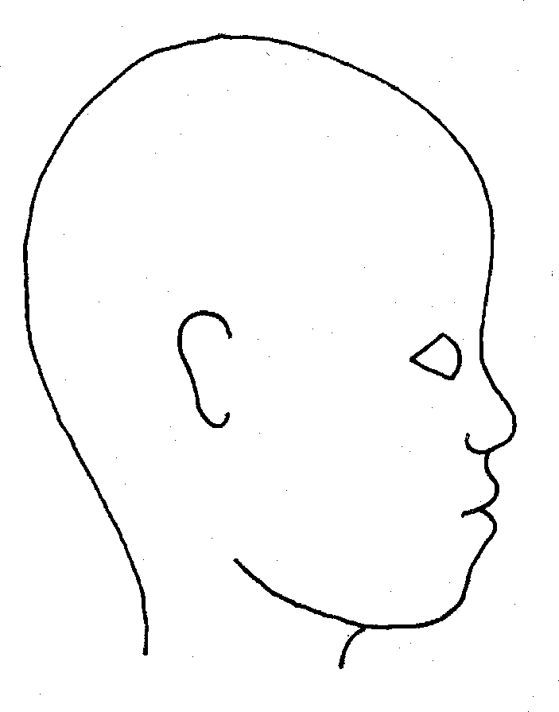
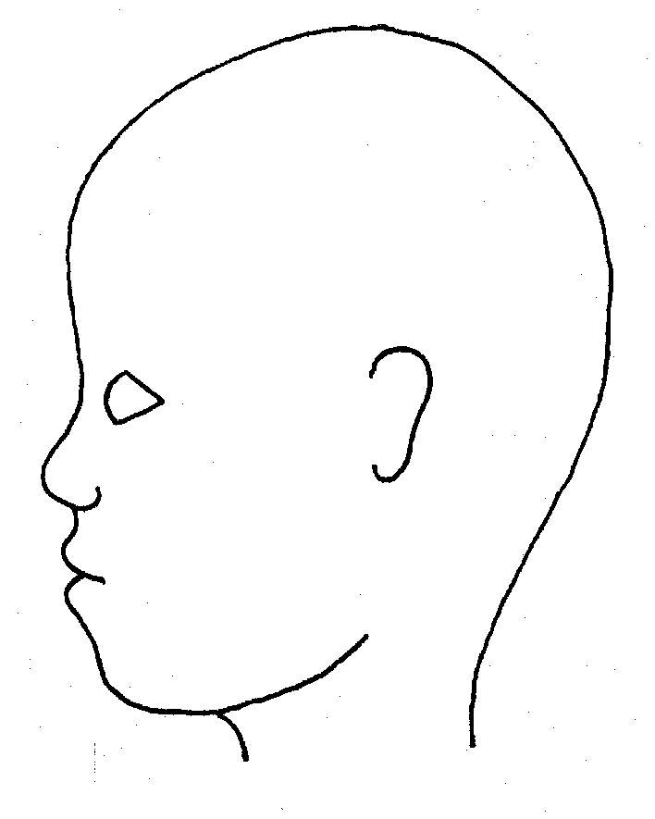
RIGHT LEFT

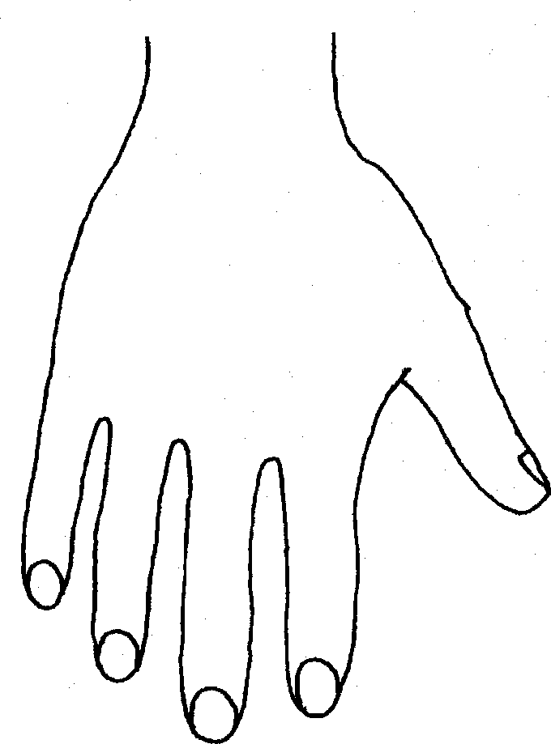   | 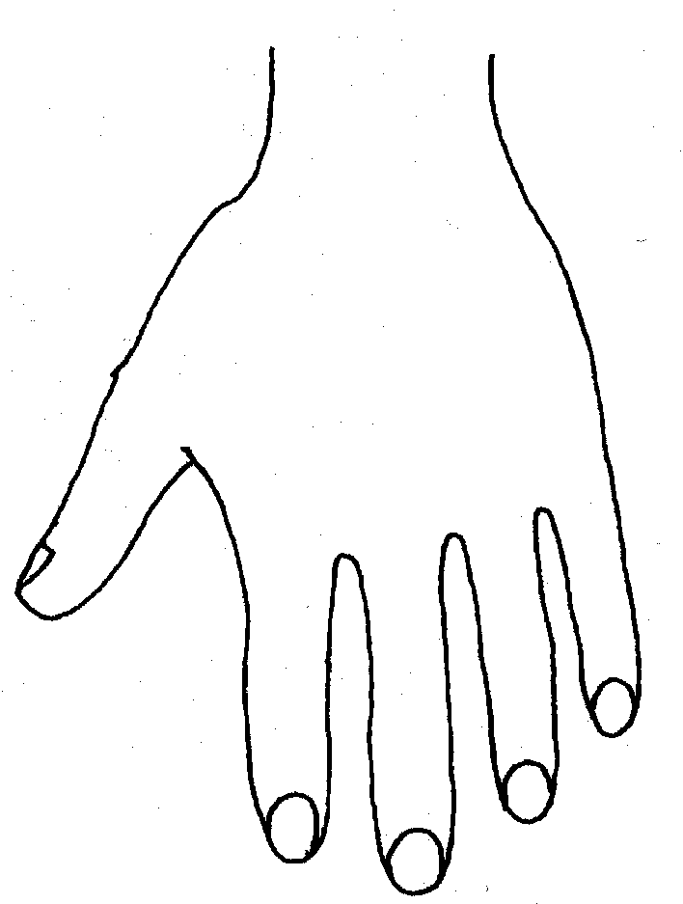  

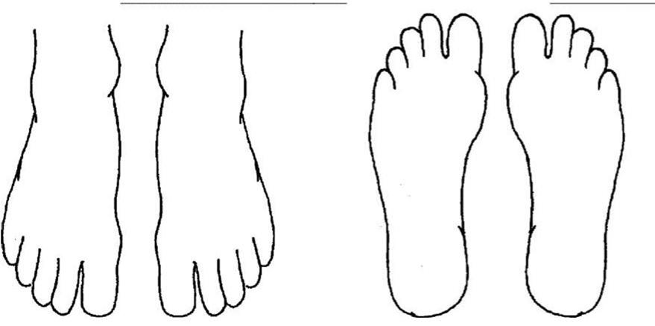
R TOP L TOP R BOTTOM L BOTTOM
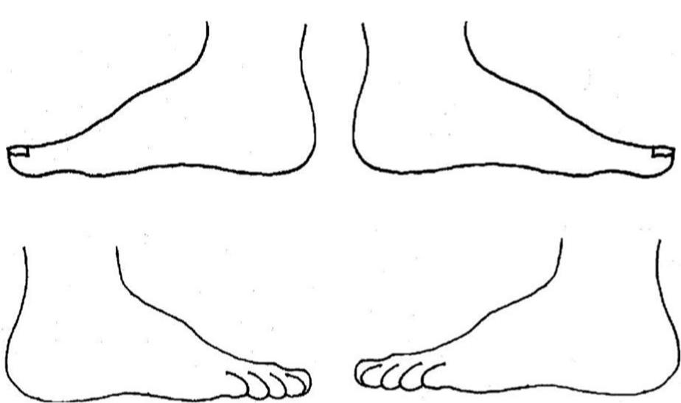
R OUTER L
R INNER L

Name:
Signature:
Job title of staff:

Appendix 9: Checklist for Staff and Governors
This checklist outlines essential responsibilities, protocols, and statutory references derived from the safeguarding policy. It is intended for use during staff induction and as part of ongoing refresher training.
Statutory References
- Ensure familiarity with 'Keeping Children Safe in Education (KCSIE) 2025'.
- Adhere to 'Working Together to Safeguard Children (2023)'.
- Understand obligations under the Children Act 1989 and 2004.
- Be aware of the Prevent Duty as stipulated by the Counter-Terrorism and Security Act 2015.
- Comply with the Equality Act 2010 and the Human Rights Act 1998.
- Have knowledge of the Independent School Standards (Part 3).

Roles and Responsibilities
- All staff are required to read Part 1 and Annex B of KCSIE annually and provide a signed declaration of comprehension.
- The Designated Safeguarding Lead (DSL) must be a senior member of the leadership team, responsible for overseeing all aspects of safeguarding and child protection.
- Deputy DSLs are to support the DSL and act on their behalf when necessary.
- Governors are expected to appoint a designated safeguarding lead and oversee full implementation of safeguarding policies.
- The Headteacher is responsible for ensuring staff receive appropriate training and that safeguarding policies are effectively communicated to parents and carers.
- The Education Director serves as an alternate DSL if required.

Safeguarding Procedures
- All concerns must be promptly reported to the DSL or Deputy DSL.
- Safeguarding concerns should be recorded using CPOMS.
- Immediate referral to children's social care or the police is required if a child is at risk of harm.
- Follow established procedures for disclosures, FGM, extremism, and mental health issues.
- Adhere to guidance on managing low-level concerns and allegations.
- Conduct contextual safeguarding risk assessments as required.

Child-on-Child Abuse and Online Safety
- Proactively challenge inappropriate behaviour and language among pupils.
- Deliver education to pupils regarding consent, healthy relationships, and online safety.
- Report any incidents of sexual harassment, violence, or sexting directly to the DSL.
- Maintain effective filtering and monitoring systems for online safety.
- Support both victims and alleged perpetrators through comprehensive risk assessments and intervention plans.

SEND and Vulnerable Pupils
- Offer additional pastoral support and assign key workers for pupils with SEND.
- Remain vigilant to barriers to disclosure and indicators of abuse within vulnerable groups.
- Implement tailored safeguarding adaptations in RSHE and tutorial programmes.
- Our school is committed to supporting gender questioning children. We recognise the importance of creating a safe and inclusive environment where all children feel respected and supported. Staff will receive training on how to support gender questioning children, ensuring that their needs are met and they feel safe within the school community.

Training and Monitoring
- Complete mandatory induction and annual safeguarding training.
- Undertake Prevent awareness training as required.
- Governors must participate in safeguarding training upon induction and at regular intervals thereafter.
- The DSL and deputies are required to complete Level 3 safeguarding training biennially.
- Review and update the safeguarding policy and associated procedures annually.

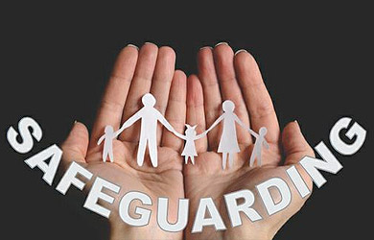

Appendix 9

Useful Contacts within the Local Authority

Children’s Social Care
Department | Email | Phone Number
Integrated front door | ChildrensIntegratedFrontDoor@barnsley.gov.uk | 01226 772423
Disabled Children’s Team | infoFIS@barnsley.gov.uk | 01226 774050

School Services
Department | Email | Phone Number
School Safeguarding Advisor | Kirsty BoothKirstibooth@barnsley.gov.uk | 01226 772 616
Education Welfare | juliehaywood@barnsley.gov.uk | 07786 525758
Virtual School | Tom Oates ThomasOates@barnsley.gov.uk

Prevent Team
Department | Email | Phone Number
Prevent Education Officer | prevent@barnsley.gov.uk  Matt Wright-Blakeman - Community Safety Officer  mattwrightblakeman@barnsley.gov.uk  Andy Barnaby – Strategic Contest Lead  andrewbarnaby@barnsley.gov.uk

Local Authority Designated Officer (LADO)
Department | Email | Phone Number
LADO | LADO@barnsley.gov.uk  Sian Christian | 01226 772341

Whistleblowing
Department | Email | Phone Number
Keys  NSPCC | whistleblowing@keys-group.co.uk
Keys  NSPCC | help@nspcc.org.uk
Independent Whistleblowing | https://secure.ethicspoint.eu/domain/en/report_custom.asp?clientid=106960 | 0800 | 374 | 199
Ofsted | whistleblowing@ofsted.gov.uk | 0300 | 123 | 3155

Police
Department | Email | Phone Number
Local Police | Barnsley Police Station | 01226 736394
South Yorkshire Police | enquiries@southyorks.pnn.police.uk | 101 / 999

