Attendance Policy
Policy Number | EDE/POL/005 | Issue Date | 01/09/2025
Issue Number | 006 | Author | Nicola Kelly
School | Oaklands Manor Schol | Approver | James Madine
Headteacher | Chris Hampton | Executive Headteacher/ Regional Director | Rob Arrowsmith

1. Introduction
This Attendance Policy reflects Keys Group’s EPIC values—Excellence, Passion, Integrity, Caring—and the Keys Connect approach, which emphasises relational, trauma-informed practices tailored to support pupils with complex needs and attendance challenges.
Keys Group schools are committed to working in partnership with pupils and families to promote and support high levels of attendance. In line with the Department for Education’s statutory guidance Working Together to Improve School Attendance (updated August 2024), our approach prioritises early intervention, relationship-building, and understanding the barriers to attendance. We recognise that improving attendance is not solely a compliance issue but a collaborative effort rooted in pastoral care, wellbeing, and inclusive practice. Our schools consistently demonstrate strong engagement with families and pupils, and we aim to build on this strength by ensuring that support is proactive, respectful, and tailored to individual needs. Attendance is monitored rigorously, and strategies are implemented to address persistent or severe absence within the use of an individualised attendance plan which always remains with the goal of re-engaging learners and fostering a culture where every day in school counts.
The policy complies with Part 3, paragraph 15 of the Independent School Standards 2014 (as amended), and the Education (Pupil Registration) (England) Regulations 2024. It recognises the unique barriers faced by many of our pupils, including historical trauma and ongoing challenges, and commits to a personalised, empathetic approach to attendance improvement.
While our aspiration is for all pupils to achieve 100% attendance, we pursue this goal sensitively and realistically, recognising that many pupils join us with persistent absence patterns.
2. Policy Aims
At Oaklands Manor School, we aim to ensure that every pupil:
- Feels safe, secure, and well cared for within the school community.
- Fully participates in school life, enjoying and achieving their potential.
- Feels valued and trusts staff to safeguard their wellbeing.
- Receives support tailored to overcome barriers to attendance.
- Understands the importance of regular attendance and punctuality.
3. Roles and Responsibilities
Role | Name
Governing Body (Chair) | James Madine
Regional Executive Headteacher/Director | Rob Arrowsmith
Head Teacher | Chris Hampton
School Attendance Leader | Chris Hampton
Daily Attendance Contact | TBC (School Administrator)

4. Reporting Absence
Parents/carers must notify the school on the first day of absence before the school day starts via ARBOR, phone, or email (07927 534817) or admin.oaklandsmanor@keyseducation.ac.uk A
rrangements for longer absences will be agreed as needed.
Parents/carers needing support with attendance should contact Chris Hampton, 07927 534817 or chris.hampton@keyseducation.ac.uk
5. Registration and Lateness
- Registration is taken twice daily AM: 0915 PM: 1300.
- Pupils arriving within 5 minutes after registration are marked late (Code L).
- Pupils arriving after 15 minutes are marked absent (Code U or equivalent).
- Persistent lateness linked to transport or external factors will be addressed collaboratively with families, transport providers, and local authorities. (Code Y1 to be used if, usual transport is not able to be facilitated).
6. Categorisation of Absence
Authorised absences include:-
- Genuine illness
- Emergency medical/dental appointments (evidence may be requested)
- Traveller pupils travelling for occupational purposes
Unauthorised absences include:-
- Family holidays
- Shopping trips
- Birthdays
7. Attendance Monitoring and Intervention
- Attendance is benchmarked on admission and monitored daily using ARBOR data.
- Patterns of absence are analysed to identify pupils or cohorts needing support monthly.
- Attendance improvement meetings are held fortnightly to review data and progress against plans.
- Positive attendance is recognised with rewards and certificates and for those children who attend 100% of the week, there is an incentive scheme for a ‘Friday morning Breakfast’. Each child also is provided with a raffle ticket on a Friday morning also to win something out of the ‘dip box’. Also weekly attendance certificates are completed and given to the children to take home to celebrate their daily achievements.
- Pupils with attendance concerns receive personalised Attendance Support Plans developed collaboratively with families.
- Home visits and safe and well checks are conducted for unexplained absences, especially for pupils known to social care within a 5-day period.
- Multi-agency collaboration is maintained to support attendance improvement. This surrounds any professionals who support the child and the family along with the EHCP co-ordinator and the Education Inclusion Team specific to the local authority that the children reside in.
8. Safeguarding and Children Missing in Education (CME)
- Unexplained absences trigger safe and well checks, including unannounced home visits where necessary. Keys policy and procedure follow a 5 day safe and welfare check to be completed, however, ‘Working together to keep children safe 2024’ highlights the importance of completing these visits within 10 days. Should a child or young person have risk factors that may place them at harm within the community, it is understood by the Attendance Lead and the Head Teacher of Oaklands Manor School that these children may need to be seen before 5 days.
- The school collaborates with social care and other agencies to safeguard pupils.
- The Local Authority is notified of pupils missing from education as per statutory guidance.
- The school cooperates fully with local authority procedures regarding CME.
9. Legal Framework
- The school adheres to the National Framework for Penalty Notices where applicable, including the new statutory guidance effective from August 2024.
- Parents have legal duties to ensure regular attendance under sections 444(1) and 444(1A) of the Education Act 1996, with penalties including fines and possible prosecution.
- The school will work with local authorities to enforce attendance where voluntary support fails.
- Penalty Notices require a preceding ‘Notice to Improve’ and follow the prescribed fine schedule (£80 within 21 days, £160 within 28 days).
10. Parental Responsibilities
Parents/carers must:
- Ensure their child attends school regularly and punctually.
- Report absences promptly with reasons or with evidence around their child’s non-attendance.
- Update the school daily during ongoing absences unless agreed otherwise.
- Request leave for exceptional circumstances in advance or as soon as possible.
- Provide evidence for planned medical appointments.
- Work collaboratively with the school and other agencies to resolve attendance barriers.
11. Training and Equality
- Staff receive training on attendance policy and its links to safeguarding.
- The policy is implemented with sensitivity to diversity and individual pupil needs.
- Any concerns regarding equality impact should be raised with line management for appropriate action.
Appendices – Procedures and Localisation of Policy
Appendix A – Tiers of Intervention around Attendance
Attendance Tier | Identifying Factor | Potential Strategies
1. Expected attendance is maintained | Pupil consistently meets their expected attendance target | - Celebrate through positive points or rewards  - Continue regular monitoring
2. Expected attendance is not consistently maintained | Patterns of poor attendance identified through data analysis | - Discuss barriers with pupil and parents/carers  - Develop and agree an Attendance Support Plan  - Monitor progress for minimum 4 weeks  - Engage external support if needed (e.g., Early Help)
3. Attendance is not improving / lack of engagement | Persistent absence despite support and engagement efforts | - Formalise support with attendance contract or Education Supervision Order  - Clearly explain consequences  - Continue multi-agency collaboration
4. Enforcement | All support avenues exhausted, no improvement or engagement | - Issue Penalty Notice in line with National Framework  - Consider prosecution to protect pupil’s right to education

Appendix B – Attendance Management Plan (Stages)
Stage | Description | Actions
Stage 1 | Attendance falls below target of 80% | - Send letter to parent/carer informing of concern  - Explain impact of low attendance  - Individualised Attendance Plan to be completed with the family, child and the surrounding multi-agency team.
Stage 2 | Continued absence and decline after Stage 1, attendance 70%-79.9% | - Send Stage 2 letter  - Arrange home visit or virtual meeting to discuss attendance and review plan that is in place.
Stage 3 | Further absence after Stage 2 attendance 69.9% and below | - Invite parents for attendance meeting within the school with the attendance lead and administrator.  - Review Attendance Support Plan and update with any new actions or positive points.  - Explain possible escalation to the Education inclusion team. Continue to positive and encouraging whilst discussing the importance education for long-term outcomes.
Stage 4 | Unauthorised absences continue after Stage 3 | - Issue Penalty Notice Warning letter (Headteacher authorised)  - Liaise with Local Authority Attendance Team
Stage 5 | Persistent absence despite penalty notice | - Request Local Authority to consider prosecution  - Continue multi-agency support

Appendix C – Attendance Codes (DfE Guidance Summary)
Code | Description | Usage
/ | Present (AM or PM) | Pupil is present in school
L | Late (before register closes) | Pupil arrives after start of session but before register closes 09:20.
U | Late- after register closes | Pupil arrives after the start of all sessions and after the closure of the register at 09:30
O | Unauthorised absence (late after register closes) | Pupil arrives after register closes without valid reason
I | Illness | Authorised absence due to illness
M | Medical/Dental appointments | Authorised absence for medical reasons (evidence may be requested)
C | Other authorised circumstances | Authorised absence for other exceptional circumstances
O | Unauthorised absence | Absence without permission or valid reason
N | No reason yet provided | Absence not yet explained
X | Not required to be in school | For example, pupils in approved off-site educational activity
B | Educated off school site | For example, Alternative Provision
Y1 | Normal transport provision unavailable | E.g. if organised transport through the local authority is not available
C2 | Pupil on a Part-Time timetable | Authorised absence due to timetable that has been agreed with school and the local authority.
K | Educated Provision organised by the local authority | e.g. The SEN local authority have organised planned education outside of South Parks offer.

Appendix D – Sample Attendance Improvement Plan

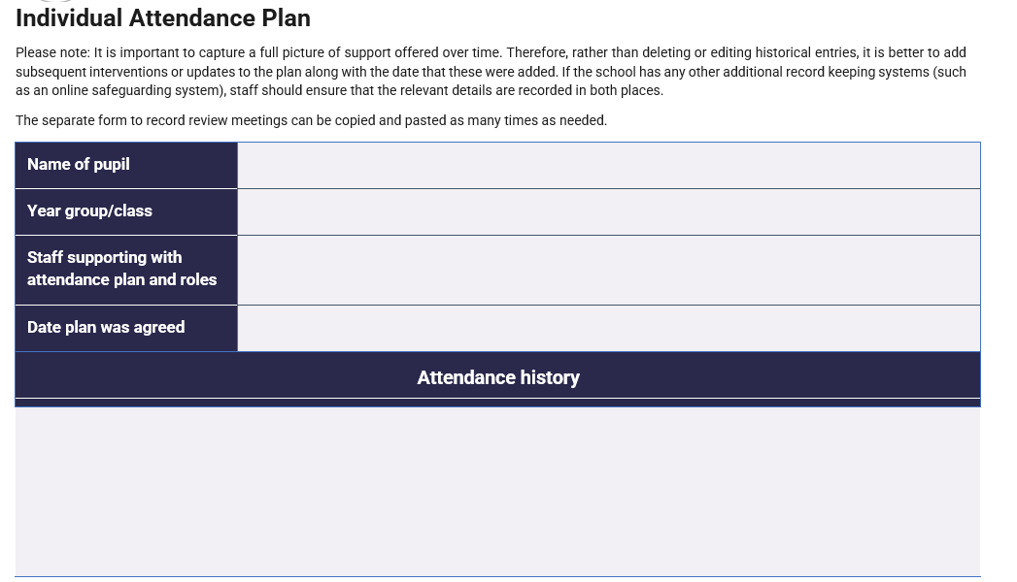
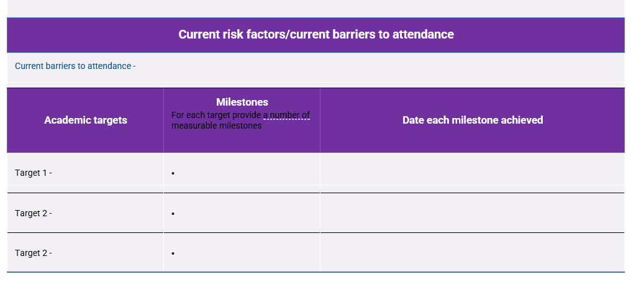
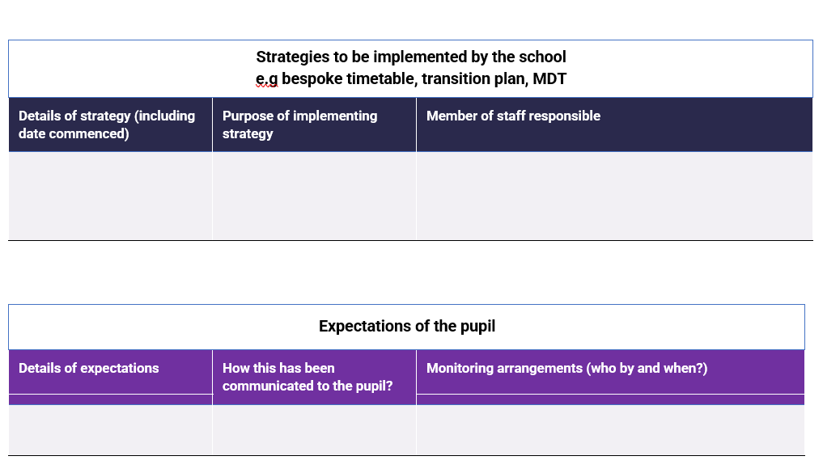
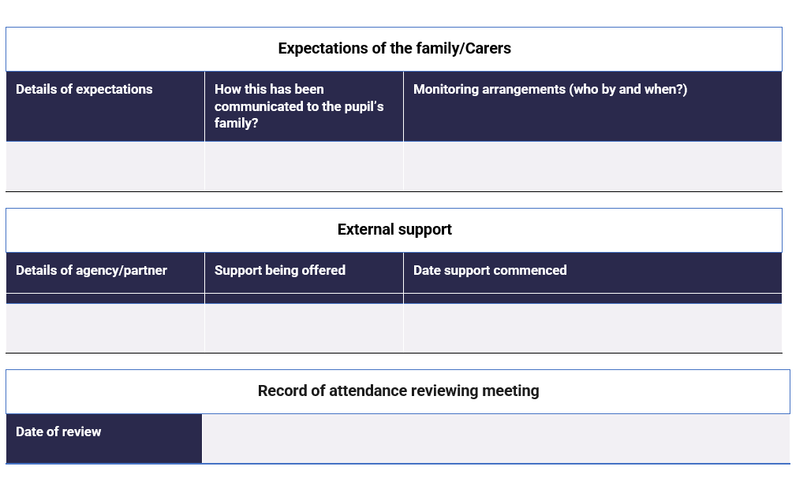
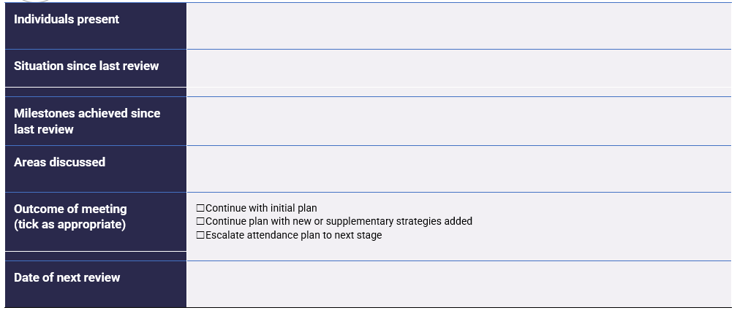
Appendix E – Sample Attendance Contract
Initial/Review Date: [Insert Date]
School: Oaklands Manor School
Pupil Name: | Date of Birth: | Year/Form Group:
Ethnicity: | Looked After: ☐ Yes ☐ No | Attendance Champion:
Form Tutor: | Head Teacher/Associate Head:
Purpose:
To improve the pupil’s attendance and address barriers.
Attendance Data:
Attendance Level (%) | Authorised (%)
Unauthorised (%) | Unauthorised Lates (%)
Identified Difficulties:
Difficulty | Yes ☐ / No ☐ | Difficulty | Yes ☐ / No ☐
1. Bullying |  | 7. Punctuality
2. Medical |  | 8. SEND
3. EBSA (Emotional Based School Avoidance) |  | 9. Academic
4. Home Issues |  | 10. Behaviour/Attitude
5. Transport |  | 11. Other
6. School Relationships
Barriers & Actions:
No. | Barrier Description | Action Plan (Start Date, Responsible Person, Review Date)
1
2

Agreement:
We agree to work together to improve attendance as outlined in this contract.
Pupil Signature: _ Date: _
Parent/Carer Signature: Date: _
School Representative Signature: _ Date:

